What is Risk?
"Tomorrow problems are today's risk." Hence, a clear definition of a "risk" is a problem that could cause some loss or threaten the progress of the project, but which has not happened yet.
These potential issues might harm cost, schedule or technical success of the project and the quality of our software device, or project team morale.
Risk Management is the system of identifying addressing and eliminating these problems before they can damage the project.
We need to differentiate risks, as potential issues, from the current problems of the project.
Different methods are required to address these two kinds of issues.
For example, staff storage, because we have not been able to select people with the right technical skills is a current problem, but the threat of our technical persons being hired away by the competition is a risk.

Risk Management
A software project can be concerned with a large variety of risks. In order to be adept to systematically identify the significant risks which might affect a software project, it is essential to classify risks into different classes. The project manager can then check which risks from each class are relevant to the project.
There are three main classifications of risks which can affect a software project:
- Project risks
- Technical risks
- Business risks
1. Project risks: Project risks concern differ forms of budgetary, schedule, personnel, resource, and customer-related problems. A vital project risk is schedule slippage. Since the software is intangible, it is very tough to monitor and control a software project. It is very tough to control something which cannot be identified. For any manufacturing program, such as the manufacturing of cars, the plan executive can recognize the product taking shape.
2. Technical risks: Technical risks concern potential method, implementation, interfacing, testing, and maintenance issue. It also consists of an ambiguous specification, incomplete specification, changing specification, technical uncertainty, and technical obsolescence. Most technical risks appear due to the development team's insufficient knowledge about the project.
3. Business risks: This type of risks contain risks of building an excellent product that no one need, losing budgetary or personnel commitments, etc.
Other risk categories
- 1. Known risks: Those risks that can be uncovered after careful assessment of the project program, the business and technical environment in which the plan is being developed, and more reliable data sources (e.g., unrealistic delivery date)
- 2. Predictable risks: Those risks that are hypothesized from previous project experience (e.g., past turnover)
- 3. Unpredictable risks: Those risks that can and do occur, but are extremely tough to identify in advance.

Principle of Risk Management
- Global Perspective: In this, we review the bigger system description, design, and implementation. We look at the chance and the impact the risk is going to have.
- Take a forward-looking view: Consider the threat which may appear in the future and create future plans for directing the next events.
- Open Communication: This is to allow the free flow of communications between the client and the team members so that they have certainty about the risks.
- Integrated management: In this method risk management is made an integral part of project management.
- Continuous process: In this phase, the risks are tracked continuously throughout the risk management paradigm.

Risk Management Activities
Risk management consists of three main activities, as shown in fig:
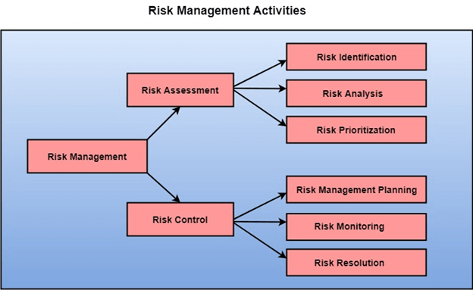

Risk Assessment
The objective of risk assessment is to division the risks in the condition of their loss, causing potential. For risk assessment, first, every risk should be rated in two methods:
- The possibility of a risk coming true (denoted as r).
- The consequence of the issues relates to that risk (denoted as s).
Based on these two methods, the priority of each risk can be estimated:
p = r * s
Where p is the priority with which the risk must be controlled, r is the probability of the risk becoming true, and s is the severity of loss caused due to the risk becoming true. If all identified risks are set up, then the most likely and damaging risks can be controlled first, and more comprehensive risk abatement methods can be designed for these risks.
1. Risk Identification: The project organizer needs to anticipate the risk in the project as early as possible so that the impact of risk can be reduced by making effective risk management planning.
A project can be of use by a large variety of risk. To identify the significant risk, this might affect a project. It is necessary to categories into the different risk of classes.
There are different types of risks which can affect a software project:
- Technology risks: Risks that assume from the software or hardware technologies that are used to develop the system.
- People risks: Risks that are connected with the person in the development team.
- Organizational risks: Risks that assume from the organizational environment where the software is being developed.
- Tools risks: Risks that assume from the software tools and other support software used to create the system.
- Requirement risks: Risks that assume from the changes to the customer requirement and the process of managing the requirements change.
- Estimation risks: Risks that assume from the management estimates of the resources required to build the system
2. Risk Analysis: During the risk analysis process, you have to consider every identified risk and make a perception of the probability and seriousness of that risk.
There is no simple way to do this. You have to rely on your perception and experience of previous projects and the problems that arise in them.
It is not possible to make an exact, the numerical estimate of the probability and seriousness of each risk. Instead, you should authorize the risk to one of several bands:
- The probability of the risk might be determined as very low (0-10%), low (10-25%), moderate (25-50%), high (50-75%) or very high (+75%).
- The effect of the risk might be determined as catastrophic (threaten the survival of the plan), serious (would cause significant delays), tolerable (delays are within allowed contingency), or insignificant.

Risk Control
It is the process of managing risks to achieve desired outcomes. After all, the identified risks of a plan are determined; the project must be made to include the most harmful and the most likely risks. Different risks need different containment methods. In fact, most risks need ingenuity on the part of the project manager in tackling the risk.
There are three main methods to plan for risk management:
- Avoid the risk: This may take several ways such as discussing with the client to change the requirements to decrease the scope of the work, giving incentives to the engineers to avoid the risk of human resources turnover, etc.
- Transfer the risk: This method involves getting the risky element developed by a third party, buying insurance cover, etc.
- Risk reduction: This means planning method to include the loss due to risk. For instance, if there is a risk that some key personnel might leave, new recruitment can be planned.
Risk Leverage: To choose between the various methods of handling risk, the project plan must consider the amount of controlling the risk and the corresponding reduction of risk. For this, the risk leverage of the various risks can be estimated.
Risk leverage is the variation in risk exposure divided by the amount of reducing the risk.
Risk leverage = (risk exposure before reduction - risk exposure after reduction) / (cost of reduction)
1. Risk planning: The risk planning method considers each of the key risks that have been identified and develop ways to maintain these risks.
For each of the risks, you have to think of the behavior that you may take to minimize the disruption to the plan if the issue identified in the risk occurs.
You also should think about data that you might need to collect while monitoring the plan so that issues can be anticipated.
Again, there is no easy process that can be followed for contingency planning. It rely on the judgment and experience of the project manager.
2. Risk Monitoring: Risk monitoring is the method king that your assumption about the product, process, and business risks has not changed.

What Is Software Risk And Software Risk Management?
Risk is an expectation of loss, a potential problem that may or may not occur in the future. It is generally caused due to lack of information, control or time.A possibility of suffering from loss in software development process is called a software risk. Loss can be anything, increase in production cost, development of poor quality software, not being able to complete the project on time. Software risk exists because the future is uncertain and there are many known and unknown things that cannot be incorporated in the project plan. A software risk can be of two types (a) internal risks that are within the control of the project manager and (2) external risks that are beyond the control of project manager. Risk management is carried out to:
- Identify the risk
- Reduce the impact of risk
- Reduce the probability or likelihood of risk
- Risk monitoring
A project manager has to deal with risks arising from three possible cases:
- Known knowns are software risks that are actually facts known to the team as well as to the entire project. For example not having enough number of developers can delay the project delivery. Such risks are described and included in the Project Management Plan.
- Known unknowns are risks that the project team is aware of but it is unknown that such risk exists in the project or not. For example if the communication with the client is not of good level then it is not possible to capture the requirement properly. This is a fact known to the project team however whether the client has communicated all the information properly or not is unknown to the project.
- Unknown Unknowns are those kind of risks about which the organization has no idea. Such risks are generally related to technology such as working with technologies or tools that you have no idea about because your client wants you to work that way suddenly exposes you to absolutely unknown unknown risks.
Software risk management is all about risk quantification of risk. This includes:
- Giving a precise description of risk event that can occur in the project
- Defining risk probability that would explain what are the chances for that risk to occur
- Defining How much loss a particular risk can cause
- Defining the liability potential of risk
Risk Management comprises of following processes:
- Software Risk Identification
- Software Risk Analysis
- Software Risk Planning
- Software Risk Monitoring
These Processes are defined below.
Software Risk Identification
In order to identify the risks that your project may be subjected to, it is important to first study the problems faced by previous projects. Study the project plan properly and check for all the possible areas that are vulnerable to some or the other type of risks. The best ways of analyzing a project plan is by converting it to a flowchart and examine all essentialareas. It is important to conduct few brainstorming sessions to identify the known unknowns that can affect the project. Any decision taken related to technical, operational, political, legal, social, internal or external factors should be evaluated properly.
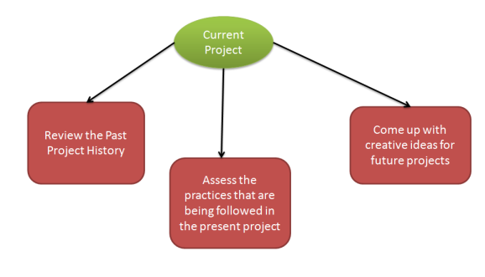
Software Risk Identification

In this phase of Risk management you have to define processes that are important for risk identification. All the details of the risk such as unique Id, date on which it was identified, description and so on should be clearly mentioned.
Software Risk Analysis
Software Risk analysisis a very important aspect of risk management. In this phase the risk is identified and then categorized. After the categorization of risk, the level, likelihood (percentage) and impact of the risk is analyzed. Likelihood is defined in percentage after examining what are the chances of risk to occur due to various technical conditions. These technical conditions can be:
- Complexity of the technology
- Technical knowledge possessed by the testing team
- Conflicts within the team
- Teams being distributed over a large geographical area
- Usage of poor quality testing tools
With impact we mean the consequence of a risk in case it happens. It is important to know about the impact because it is necessary to know how a business can get affected:
- What will be the loss to the customer
- How would the business suffer
- Loss of reputation or harm to society
- Monetary losses
- Legal actions against the company
- Cancellation of business license
Level of risk is identified with the help of:
Qualitative Risk Analysis: Here you define risk as:
- High
- Low
- Medium
Quantitative Risk Analysis: can be used for software risk analysis but is considered inappropriate because risk level is defined in % which does not give a very clear picture.
Software Risk Planning
Software risk planning is all about:
- Defining preventive measure that would lower down the likelihood or probability of various risks.
- Define measures that would reduce the impact in case a risk happens.
- Constant monitoring of processes to identify risks as early as possible.
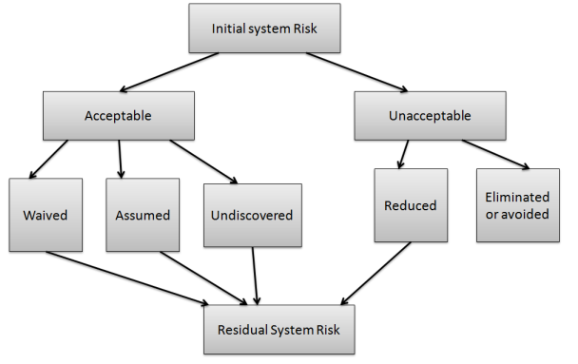
Software Risk Planning
Software Risk Monitoring
Software risk monitoring is integrated into project activities and regular checks are conducted on top risks. Software risk monitoring comprises of:
- Tracking of risk plans for any major changes in actual plan, attribute, etc.
- Preparation of status reports for project management.
- Review risks and risks whose impact or likelihood has reached the lowest possible level should be closed.
- Regularly search for new risks

Methods for Identifying Risks

Identifying risk is one of most important or essential and initial steps in risk management process. By chance, if failure occurs in identifying any specific or particular risk, then all other steps that are involved in risk management will not be implemented for that particular risk. For identifying risk, project team should review scope of program, estimate cost, schedule, technical maturity, parameters of key performance, etc. To manage risk, project team or organization are needed to know about what risks it faces, and then to evaluate them. Generally, identification of risk is an iterative process. It basically includes generating or creating comprehensive list of threats and opportunities that are based on events that can enhance, prevent, degrade, accelerate, or might delay successful achievement of objectives. In simple words, if you don’t find or identify risk, you won’t be able to manage it.
The organizer of project needs to expect some of the risk in the project as early as possible so that the performance of risk may be reduced. This could be only possible by making effective risk management planning.
A project may contain large variety of risk. To know the specific amount of risk, there may be chance of affecting a project. So, this is necessary to make categories into different class of risk.
There are many different types of risks which affects the software project:
1. Technology risks
2. Tools risks
3. Estimation risks
4. People risks
5. Requirement risks
6. Organizational risks
Methods for Identifying Risks : Earlier, there were no easy methods available that will surely identify all risks. But nowadays, there are some additional approaches available for identifying risks. Some of approaches for risk identification are given below:
1. Checklist Analysis – Checklist Analysis is type of technique generally used to identify or find risks and manage it. The checklist is basically developed by listing items, steps, or even tasks and is then further analyzed against criteria to just identify and determine if procedure is completed correctly or not. It is list of risk that is just found to occur regularly in development of software project. Below is the list of software development risk by Barry Boehm- modified version.
Risk | Risk Reduction Technique
Personnel Shortfalls | Various techniques include training and career development, job-matching, teambuilding, etc.
Unrealistic time and cost estimates | Various techniques include incremental development, standardization of methods, recording, and analysis of the past project, etc.
Development of wrong software functions | Various techniques include formal specification methods, user surveys, etc.
Development of the wrong user interface | Various techniques include user involvement, prototyping, etc.
2. Brainstorming – This technique provides and gives free and open approach that usually encourages each and everyone on project team to participate. It also results in greater sense of ownership of project risk, and team generally committed to managing risk for given time period of project. It is creative and unique technique to gather risks spontaneously by team members. The team members identify and determine risks in ‘no wrong answer’ environment. This technique also provides opportunity for team members to always develop on each other’s ideas. This technique is also used to determine best possible solution to problems and issue that arises and emerge.
3. Casual Mapping – Causal mapping is method that builds or develops on reflection and review of failure factors in cause and effect of the diagrams. It is very useful for facilitating learning with an organization or system simply as method of project-post evaluation. It is also key tool for risk assessment.
4. SWOT Analysis – Strengths-Weaknesses-Opportunities-Threat (SWOT) is very technique and helpful for identifying risks within greater organization context. It is generally used as planning tool for analyzing business, its resources, and also its environment simply by looking at internal strengths and weaknesses and opportunities and threats in external environment. It is technique often used in formulation of strategy. The appropriate time and effort should be spent on thinking seriously about weaknesses and threats of organization for SWOT analysis to more effective and successful in risk identification.
5. Flowchart Method – This method allows for dynamic process to be diagrammatically represented in paper. This method is generally used to represent activities of process graphically and sequentially to simply identify the risk.

